Introducing New Ways to Give…

We thank you for your generosity in partnering with [name of your church] in our ministry here at this church. The ministry of [church name] would not be possible without the gifts and donations from generous individuals like yourself.

There are new ways to give – faster, easier and more flexible – and much more in tune with how people are now handling their finances. [church name] has a story to tell… one that makes our church one of the best places for people to give to minister to our community. These new tools allow us to make the experience of giving together as simple and joyful as possible.

Using Tithe.ly, there are now 3 new easy ways you can conveniently give both one-time and recurring donations:
- Directly from our church website.
- Through a computer/tablet setup at our church.
- Download the Tithe.ly app and give through your phone

Some things you should know…
- Can I still give by cash or cheque? Of course you can! The existing methods of giving will remain intact. These new tools just add addition ways to give that some may find more convenient.
- Can I give from my bank account? Tithe.ly currently accepts only Credit Cards in Canada. However, if you have one of the new bank debit cards with an expiry date and CVS code on the back, you can enter it as a credit card to have your donation debited from your bank account.
- Do I have to have a Tithe.ly account to give? No! You can absolutely donate, register, or pay without signing up for a Tithe.ly account except for when using text-to-give or the Tithe.ly mobile app where having an account is required. But having a Tithe.ly account will let you securely store your payment method and other required information (so you don’t have to type it out each time). It will also let you setup/cancel/change a recurring donation, see your giving history, and manage your account yourself 24/7.
- How do I give to multiple funds at one time? Tithe.ly makes it simple for you to give to as many funds as you'd like. Once on the giving form, look for the icon of a + sign with words "Add Gift" next to it. Click on that link to add a new gift. (You can click on it as many times as you'd like)
- How do I set up a recurring gift? Simply turn on the "Setup automated giving" option and select your preferred giving schedule. Your recurring giving options are every: week; 2 weeks; month; and the 1st and 15th of every month.
- What does ‘Cover the ‘Card Processing Fee’ mean? This option (when checked) will add the cost of the processing fee to your donation. It is a small but generous way to help the church which leaves more money for ministry.

Steps to give directly from our church website:
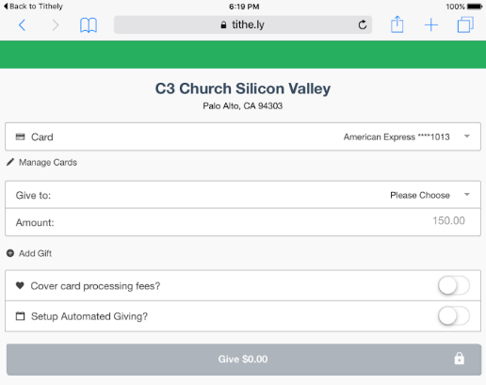
- Go to our Church Website:
[ www.yourchurchname.com]
- Click on the ‘Give Now’ button
- Complete the Giving Form
- Press the ‘GIVE!’ button at the bottom. You will be asked to confirm and then you are done!
You will also get an email in a couple minutes confirming your donation to our church.

Steps to give using the Tithe.ly App:
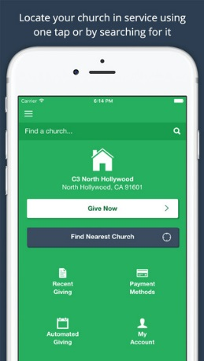
- First, you must download the Tithe.ly app for your smartphone, search “Tithely” in your smartphone’s app store (Android or iOS).
- Once you've downloaded and installed the Tithe.ly App on your smartphone, create your account by clicking “Create Account”.
- After your account is created you can search for your home church by using the search box located at the top, or you can click on the "find nearest church" button if you're near where your church meets.
- When you've found your church and are ready to give just click the “Give Now” button and complete the giving form!

